Hyper-V space reduction on Windows 10

## Step 1: Prerequisites

The following prerequisites are required to successfully run Client Hyper-V on Windows 10:

* [Hyper-V installation on Windows 10](https://github.com/KatharaFramework/Kathara/blob/master/doc/HyperV.pdf)
* Docker is installed and has been used but is **NOT** running during this procedure.

## Step 2: Access Hyper-V Manager console

1. Access Hyper-V Manager as Administrator from “Administrative Tools” menu selection on the Start Menu  
      
   [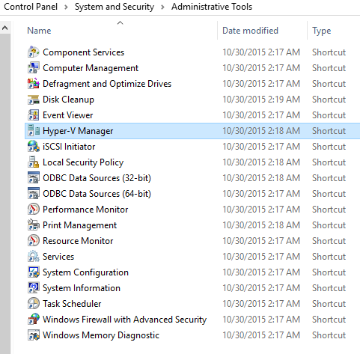](https://msdnshared.blob.core.windows.net/media/TNBlogsFS/prod.evol.blogs.technet.com/CommunityServer.Blogs.Components.WeblogFiles/00/00/00/48/12/6116.HVW8a.jpg)
2. Click on “Edit Disk“ in the right menu

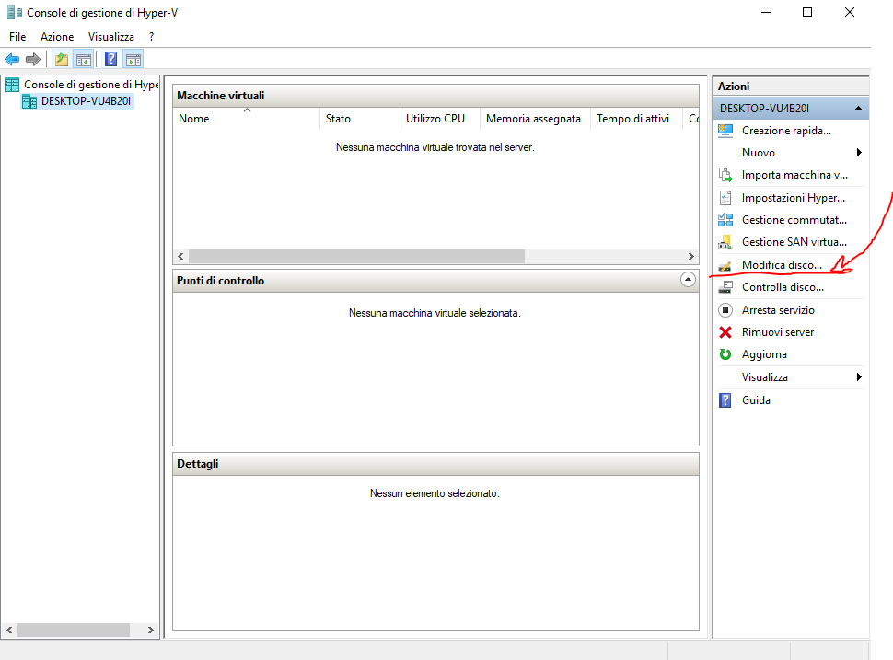

1. Go forward and select the Moby Linux dick that usually corresponds to Docker

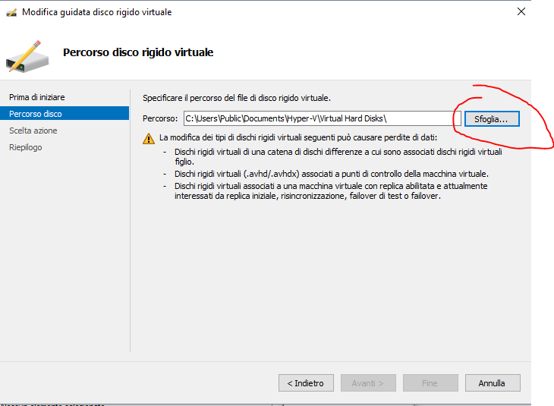

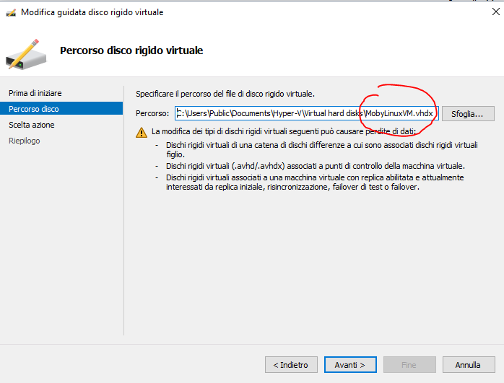

1. Select “Compact” and end the procedure.    
      
   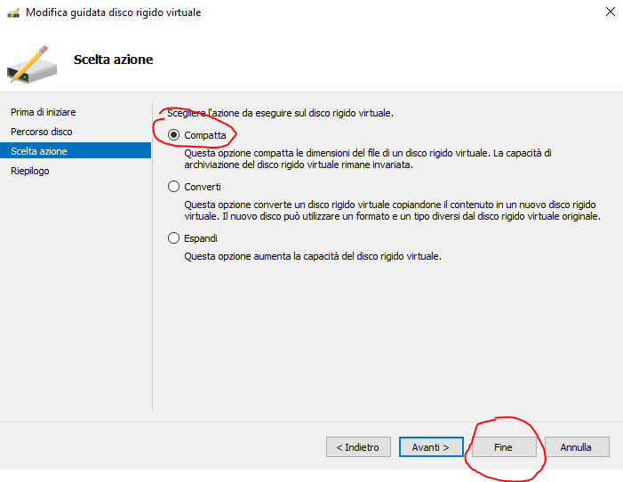
2. Wait for the procedure to end and enjoy your free disk space.